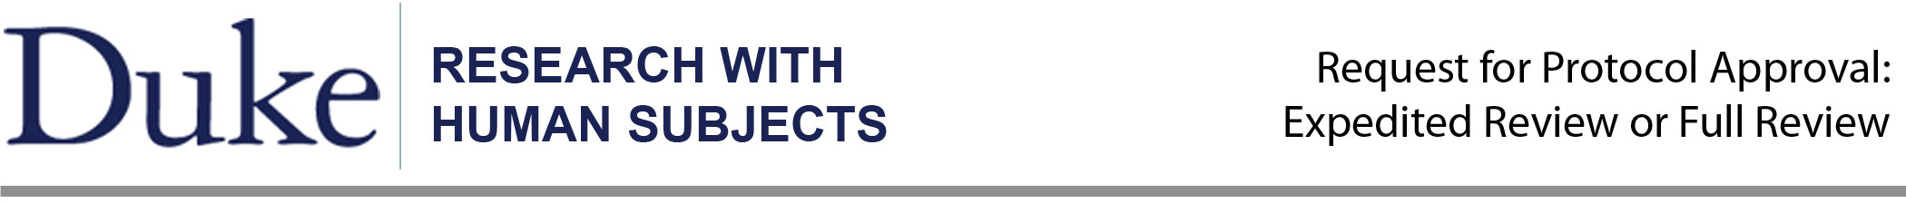
Do not use this form if:
- you are an undergraduate; instead, go to: http://ors.duke.edu/undergraduate-research, or
- your research activities are limited to analysis of data collected by someone else; instead, go to http://ors.duke.edu/Research-with-Human-Subjects/forms for the “Secondary Analysis of Existing Data” form.

Check the type of review requested, or leave blank for IRB staff: [ ] Expedited Review [ ] Full Review

Submit this form and required attachments:
- Mail Parts A and B with original signatures to: Office of Research Support, Suite 710, Erwin Square, 2200 West Main Street, Durham, NC 27705.
- Send Parts A, B, your project description prepared using the instructions in Part C, and any appendices as one Word file by e-mail to ors-info@duke.edu.

Contents:
- Investigator and Project Information
- Investigator Assurances
- Instructions for Preparing Research Description and Appendices

A. Investigator and Project Information

Project Title: Prize – Linked Savings

Fill in one box below as appropriate.

Research by Faculty or Administrators
Investigator(s): _Dan Ariely__________________________________________________________________

[ X ] Faculty [ ] Administrator [ ] Other Research Staff: _________________________

Department/School: Fuqua School of Business_ E-mail:_dan@danariely.com_ Phone: 660-7703

(Add more lines if needed)

Research by Graduate Students, Post-Doctoral Researchers, and Their Advisors
Student/Fellow Investigator(s) Seher Merve Akbas

[ X] Graduate Student [ ] Postdoctoral Fellow

Department/School: Economics E-mail: merve.akbas@duke.edu Phone: 919-328-0080

(Add more lines if needed)

Faculty Advisor(s) ______Dan Ariely____________________________________________________________

Department/School: _same as above___________ E-mail:________________ Phone: ________________

Project Information:

1. Source of Funding: Self Funded __________________________________________________
(If research is externally funded, submit a copy of the application or the award.)

2. If Federally Funded, Proposal/Grant Number: _____________________________________________

3. Research Site: Kenya _____________________________________________________________

4. Will the research take place in public elementary or secondary schools? Yes No
If yes, are the schools in the Durham? Yes No

4. Potentially Vulnerable Subject Populations: Please check all that apply (if any).
Minors, as defined at research site (under 18 years old in NC)
Psychology and Neuroscience Undergraduate Subject Pool
Other Duke research subject pool. Please specify: ________________________
Students or employees of the researcher
Prisoners
B. Assurances (Original signatures are required for final approval.)

Section 1: All researchers.
Section 2: Responsible advisors for research by students and fellows.

Section 1: Investigator(s) Assurance (Required for all researchers listed in Part A, Investigator and Project Information)

I affirm the following:

- The research will not be initiated until written approval is secured from the IRB. (Note: Approval will not be provided unless certification to conduct research with human subjects is current for the investigator[s], and if the investigator is a student, the advisor’s certification is also current.)
- I will conduct this study as described in the approved protocol. If any changes are anticipated, I will submit a Request to Amend an Approved Protocol, and I will not implement the changes until I receive approval from the IRB. I will contact the IRB staff immediately if any of the following events occur: unanticipated problems involving risks to subjects, protocol deviations, and findings during the study that would affect the risks participation in the study.

______________________________________ ________
Investigator Date (Add more lines if needed)

Section 2: Faculty Advisor:

I affirm that that I have read and approved the protocol, and I assume responsibility (1) for ensuring that student researchers are aware of their responsibilities as investigators, and (2) that the IRB will be immediately informed in the event of research-related unanticipated risks, protocol deviations, or findings during the study that would affect the risks of participation in the study.

______________________________________ __________
Faculty Advisor Date (Add more lines if needed)
____________________________________________________________________________________________
For IRB use only

Approved as: Full [ ] Expedited [ ]

APPROVAL: ____________________________________________ ________
IRB Member or Human Subjects Program Director Date
C. Instructions for Preparing the Request for Protocol Approval

To Facilitate Review of the Protocol:

- Avoid the use of discipline-specific jargon. Reviewers come from a variety of academic disciplines and also from the community.

- Provide sufficient information for the reviewers to be able understand what your subjects will experience from recruitment onward.

- Use titles for the nine sections as described below.

- Paginate the protocol and label the appendices.

Research Description (some description prompts may not apply)

1. Research Design

The purpose of this study is to test whether Prize Linked savings accounts can motivate low income individuals save more than the traditional savings products. With a prize linked savings account depositors periodically receive a chance to win a specified (and potentially large) prize that is a function of deposit amounts, in contrast to a fixed interest.

Saving is vital to the lives of the poor. Regular savings allows for smoothing of consumption, purchases of durable goods, investments in human and physical capital, and mitigation of personal and financial shocks. Moreover, since the poor are more vulnerable to a disaster or a shock, even a modest amount of savings will obviate the need for them to engage in detrimental methods (for instance, taking children out of school) to avoid large consumption drops (Chetty and Szeidl (2007)). Thus, encouraging the poor to save may have large social and private benefits and recent studies have focused on how to develop this behavior.

Despite the plethora of benefits that access to savings provides, it is often the case that the poor do not act as homo economicus in response to extensions of traditional savings accounts. Karlan and Zinman (2012) find that demand for savings accounts is unaffected by offered interest rates, in contrast to a similar study that showed a negative relationship between demand for microcredit and price1. Neither is demand driven by account availability or opening cost; Dupas et al. (2012) find that 40% of individuals offered a free bank account refused, and that even among those that did open a free account, over 80% did not actively use it.

On the other hand, lotteries are very popular among the poor. Both in the developed and in developing countries, low-income people spend a larger percentage of their incomes on lottery tickets than do the wealthier segments of society. Could this mechanism be used to motivate low – income people to save more for their future? Finding the answer is the purpose of this study.

We want to test this mechanism in a field experiment in Kenya for two reasons: First, Kenya is a developing country with a high percentage of low-income population. Second, despite low coverage of bank accounts, almost 70% of the adult population has access to a mobile money account. A mobile money account is an account linked to the mobile phone and allows user to store up to a certain amount of money and more importantly to transfer and receive any amount of money to and from other mobile money accounts. Thus the majority of the low-income population has access to a financial product, which will allow us to set up a system to test our hypothesis.

The procedure:

Participants will be invited to the Behavioral Lab in Nairobi to participate in a research study. In the lab they will be given decision tasks, which will measure their time preferences, risk preferences and gambling tendency. (An early draft of decision tasks is included in the appendix) At the end of the session, they will be invited to join a savings program for a month (the length of the period might change to 15 days or any number of days between 15 and 30).

We will have three between subjects conditions and participants in each condition will be offered one of the products below:

Interest: Participants in this group will be offered commitment savings account with interest that accrues daily. They will be asked to deposit XX or more shillings per day. And the pre-specified interest will be added to their account at the end of each day.

Lottery: Those in the lottery group will participate in a “lucky numbers” lottery. Deposits in the lottery accounts do not earn interest; instead, deposits serve as “lottery tickets” that can earn a large lump-sum payoff each day. The lottery ticket will consist of 2 numbers 1-31 (inclusive) and will be sent in a txt message upon receipt of the necessary deposit. On the morning of the following day, the winning lottery numbers will be sent out in a text message. Winners will receive the prize as additional deposits to their accounts. Note that those who do not win the lottery keep their account deposits; there is no risk of losing any deposits.

Lottery + Regret: The lottery + regret condition works similar to the lottery treatment. The only difference is that these participants will be sent their lottery ticket in the morning even if they didn’t save that day. Then they will be instructed to deposit XX or more shillings over the day to “keep” the ticket. Those who have deposited the sufficient amount keep the ticket and are eligible to win the lottery, while those who have not, will not be able to get their prize even if they win that day.

Participants will be assigned to one of these conditions randomly before they start the lab decision tasks.

At the end of the saving period (between 15-30 days), we will conduct a phone survey with the participants asking questions on their overall savings behavior as well as how much they gambled during the research study period.

The lab part of the experiment will be administered by the local researchers of the Behavioral Lab in Nairobi (Busara Center) in the presence of the graduate student Merve Akbas.

2. Subject Selection

Subjects will be recruited from the current subject pool the behavioral lab in Nairobi (Busara Center http://www.busaracenter.org) maintains. Their subject pool consists of mainly low-income inhabitants of a slum near Nairobi, called Kibera. The lab announces new experiments via a text to the subject pool.

We plan to employ about 200 subjects.

3. Risks and Benefits

There is no risk associated with this research.
Potential benefit to the participants is that they can save with our product for a month and use these savings for a goal.

- Confidentiality

We will not collect identifying information from participants.

5. Compensation

Participants will be paid for the lab part of the study upon departure, either cash or via mobile transfer.

At the end of the savings period (the end of the field part of the experiment) they will be given back their savings with interest (or the prizes they won) via mobile transfer to their private accounts associated with their mobile phone.

6. Informed Consent

CONSENT TO PARTICIPATE

You are asked to participate in research project conducted by researchers at Duke University, Dan Ariely (dan@danariely.com) and Seher Merve Akbas (merve.akbas@duke.edu). The purpose of this project is (1) to understand how people make decisions about money, (2) how people make risky decisions, (3) how people decide to save money.

During the study in the laboratory, you will be presented a number of decisions involving money. Your payment will depend on your decisions and specific rules about it will be explained to you before you start.

Your participation in this project is completely voluntary and you are free to withdraw from it at any time. During the project, all the information about you will be analyzed anonymously and reported by groups.

Do you have any questions that you would like to ask now?

For any future questions or concerns about the project, please contact the researcher Seher Merve Akbas via e-mail (merve.akbas@duke.edu) or phone (+1919-328-0080) or Dan Ariely via e-mail (dan@danariely.com). If you any questions about your rights as a research subject please contact ors-info@duke.edu.

I have read this information, and would like to participate

Name: _________________________________ Date:_____________________

7. Deception

There is no deception in this study.

8. Debriefing

As there is no deception, there will be no debriefing.
9. Appendices

Appendix I:

The time and risk preference task descriptions, which will be used in the lab part of the experiment. The payouts might be changed but the structure will stay the same.

Game instructions for Time and Risk preference

Note: None of the economic games involve deception. All choices, probabilities and outcomes are made explicit and any payment promised is certain. As is typical in economic experiments with multiple interventions, we may employ probabilistic payouts. That is, subjects make decisions and earn money in multiple tasks, but the actual payout is probabilistically chosen from one of the tasks, or one of the rounds of the task. This is to prevent income effects and portfolio effects that may bias results. The probabilities of payout for each game will be made explicit to the subjects.

Risk 1: In this task subjects are endowed with an amount of money, M, that is theirs to keep. They may invest this money in an asset, which pays P times the amount invested with probability 0.5, and pays 0 with probability 0.5. In the example screenshots, M = 50ksh, P = 4. Thus a subject who invests all of his endowment in the asset has a 50% chance of earning 200 ksh, and a 50% chance of earning 0 ksh.

Risk 2: In this task subjects must choose from a list of payouts the one that he/she prefers. The payouts are determined by a ‘coin flip’ (via computer) and both heads and tails have differing payouts for each choice. There are 6 possible choices, and the expected value of the payoffs increase along with the variance. Subjects choose from the menu which payoff set they would like to have. Then the computer flips a coin and determines which payoff they have earned.

Time Preference: In this task subjects choose between a smaller amount of money in the near term vs. a larger amount of money in the far term. The amounts of money and terms will vary as subjects answer questions. This allows us to determine their degree of time preference. For example, we may ask a subject if they prefer 100 ksh today or 200 ksh in 1 month. If they choose the money today, we can ask them another question to understand their indifference point. We might ask them if they prefer 100 ksh today or 300 ksh in one month. Depending on their choices, they may be paid sometime in the future. This will be accommodated through the use of mobile money.

Appendix II:

Screenshots of time and risk preference questions

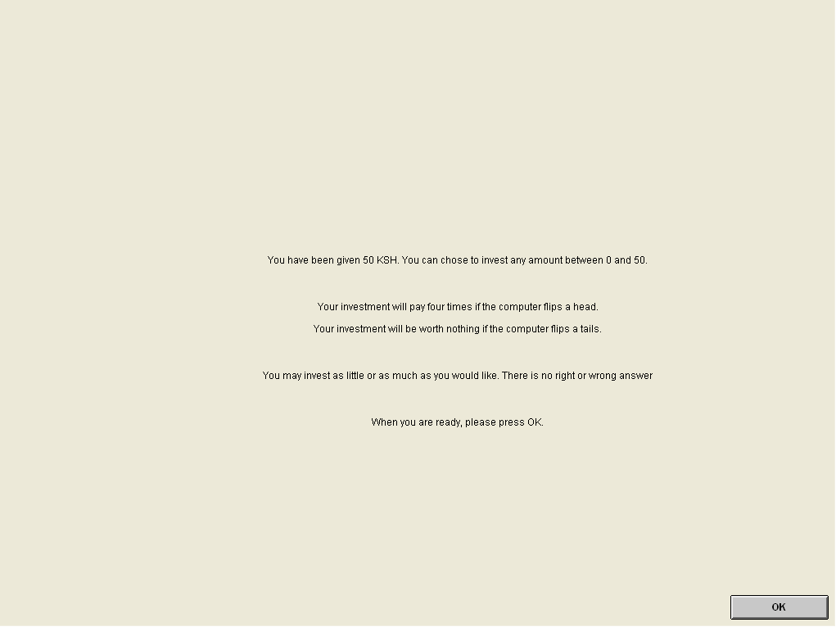

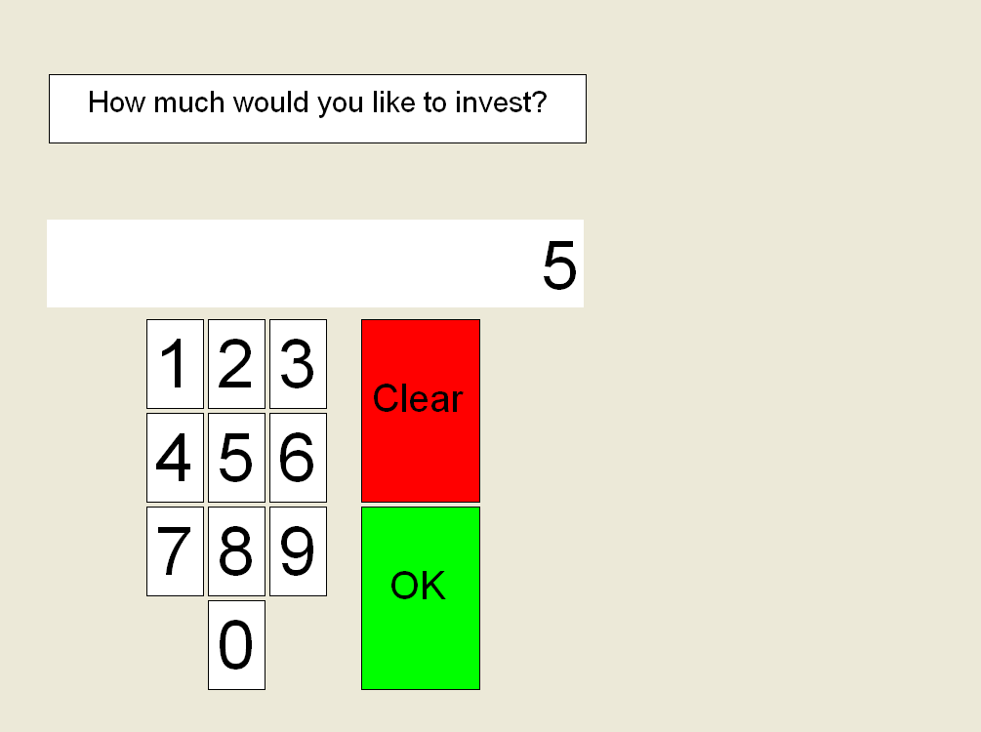

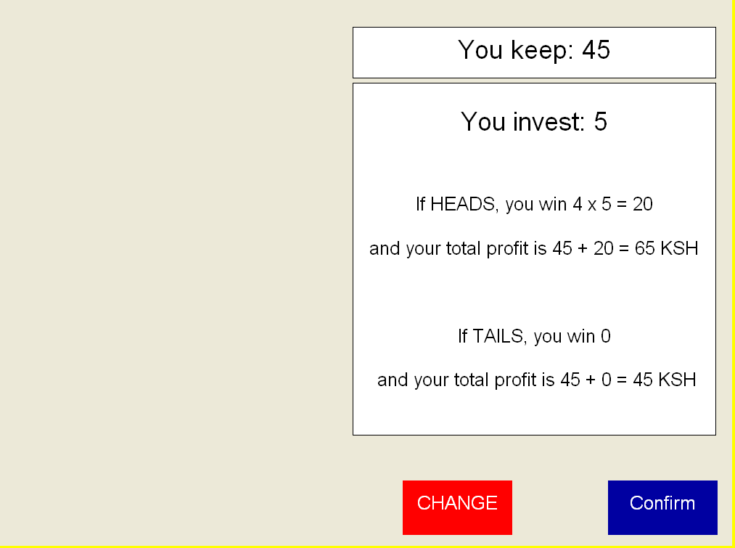

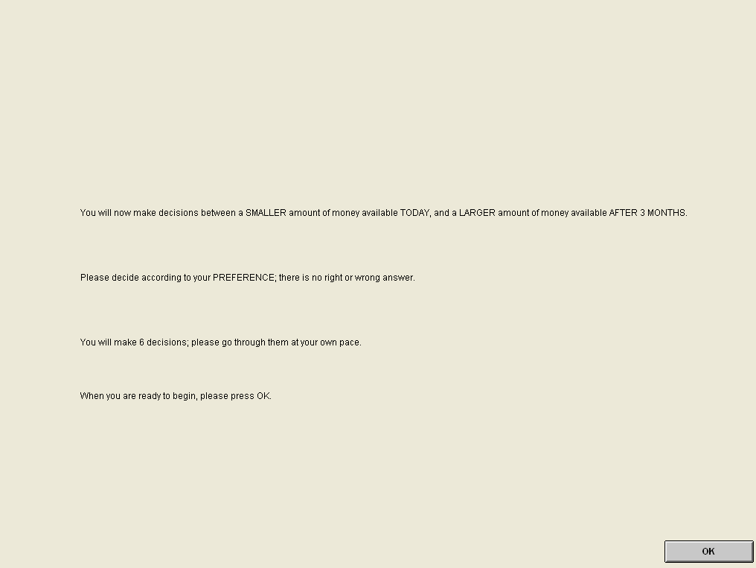

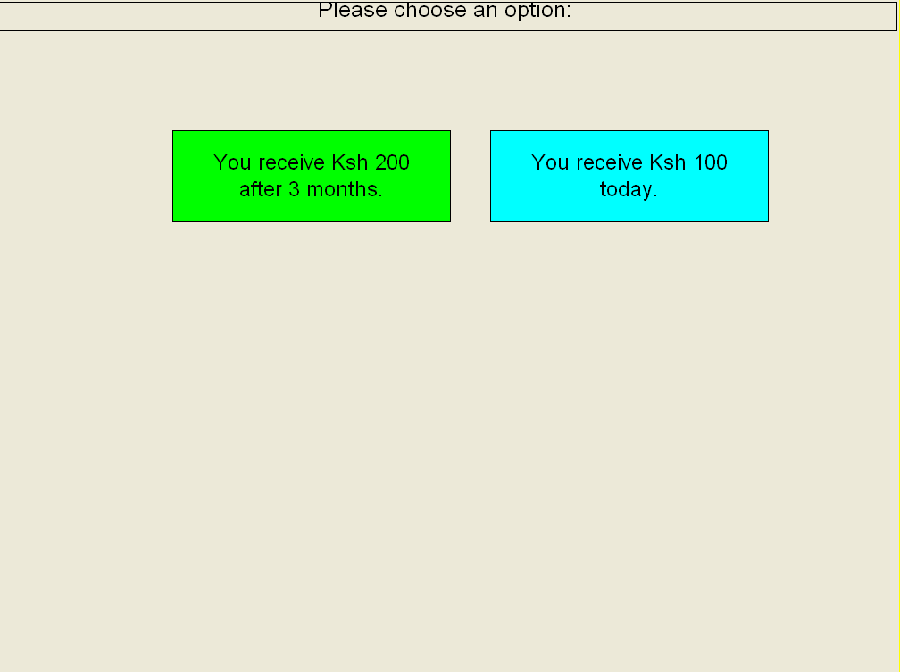

Appendix III:

Sample questions for gambling assessment. Some of these might be taken out and some questions in the context of Kenya might be added.

In the last 12 months how often have you ?
- Bet more than you could really afford to lose?
- Needed to gamble with larger amounts of money to get the same feeling of excitement?
- Gone back another day to try and win back the money you lost?
- Borrowed money or sold anything to get money to gamble?
- Felt that you might have a problem with gambling?
- Felt that gambling has caused you health problems, including stress and anxiety?
- People criticized your betting or told you that you have a gambling problem, whether or not you thought it was true?
- Felt your gambling has caused financial problems for you or your household? Felt guilty about the way you gamble or what happens when you gamble?
Scoring: 0 = Never, 1 = Sometimes, 2 = Most of the time, 3 = Almost always.

